2.1 Chassis Base

The base of the robot will be a simple, symmetrical design. It will be made out of a flat piece of wood in order to reduce weight and the risk of electrical shorts through the body of the robot.

2.2 PCB Storage Box

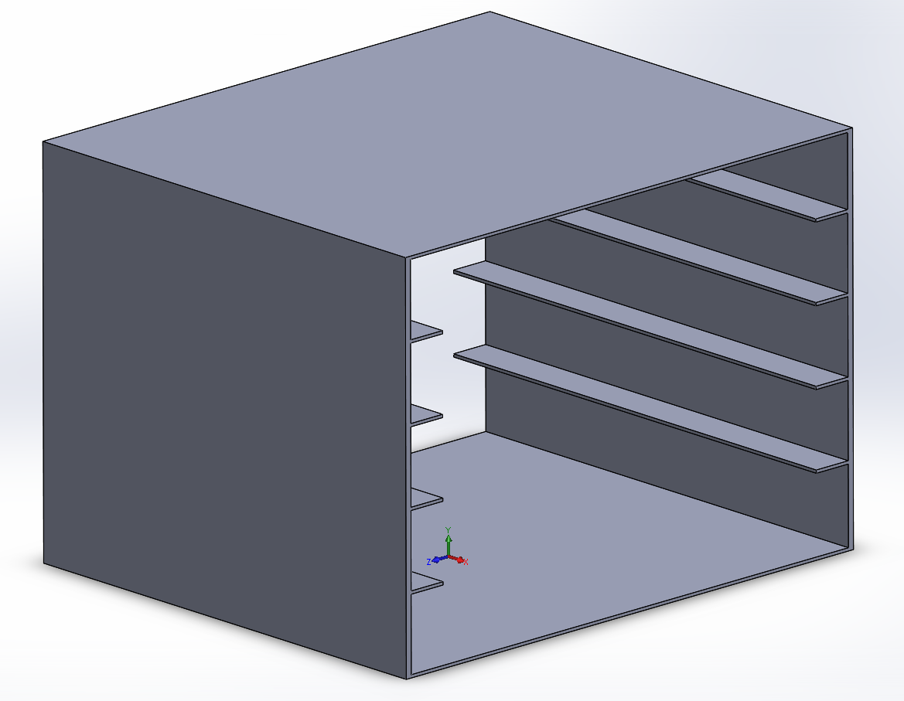

The large PCBs will be stored in a circuit tray (which will be mounted on its side). This tray will be in the middle of the robot, most likely under the arm (which will be supported separately). It will be made out of a nonconductive material such as plastic or wood. The TINAH board will be in spare space at the front of the robot, and will be placed so that it is easily accessible (on top).

2.3 Pet Basket

<- add basket section here